4.8 Write Quadratic Equations - Given the Roots and a Point
y = a(x – p)(x – q) Write each quadratic equation in standard form: y = ax² + bx + c.

2. Roots:( -6,0),(7,0) Point: (-5, -12)

3. Roots: (-5,0),(-1,0) Point: (-2, 3)

4. Roots: 1, 5 Point: (2, -6)

5. Roots: -8, -4 Point: (-5, 9)

6. Roots: (0,-3),(0, 1) Point: (-2, 6)

7. Roots: -6, -2 Point: (-1, 15)

9. Roots: -6 + $\sqrt{3}$ , -6 – $\sqrt{3}$ ; a = 1

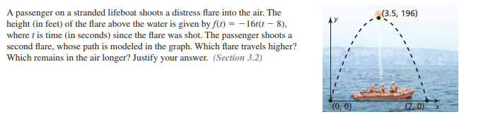
2 parts
12.

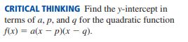
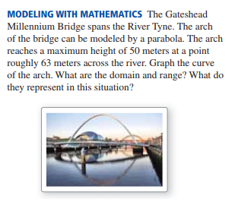
3 parts
13. 14.

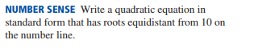
BONUS (5 points)

